INT-404

Artificial Intelligence

Topic:

Optimal Path Traversal

Submitted to:

SAGAR PANDE SIR

Submitted by:

ARYAMAN SINHA

Roll No: RK18KKA27

Reg No: 118014531

ABSTRACT

The given topic was optimal path traversal. The basic concept is to find the shortest or the most cost-effective path to traverse a graph. Here the graph is in form of a maze with ‘0’ and ‘1’ representing free and blocked paths respectively. Astar algorithm is used to implement the same. There are two functions one for Astar algorithm and other to create the maze. There is also a class named node used to create nodes for each path (free or blocked) in the maze.

RELATED WORK

There are many works related to this topic.

The Navigation System of Googles Maps is one of the advance implementations of this given problem. The traveling salesman problem is also an example. It is not only used for navigation but also to solve puzzles and games such as tic-tac-toe, 8-puzzle, also the Water Jug problem can solve as all their solution consists of path instead of state.

There are many real-world problems which uses its application like discovery of protein complexes, image segmentation, web advertisement, computational linguistic, etc.

IMPLEMENTATION

The code consists of one class and three function.

Class Node:

-consisting of two function (init and eq) five members (parent, position, f, h, g)

-Init function is a constructor and eq is used to compare nodes

Function Astar:

-consists of three argument (maze, start, and end)

-implements astar algorithm with the help of heuristic functions (f, g, h)

-the heuristic function is taken as f=h+g and

Function Create Maze:

-consists of one argument (n) which helps to get the size of the square maze

-used to create maze but putting the blocked path at random position in one row (maximum number as per the user)

-returns the maze in matrix form

Function Main:

-used to implement the program in order

-also has a menu to choose either to display the maze or from the algorithm

-the input for the start and end nodes are taken here

Result

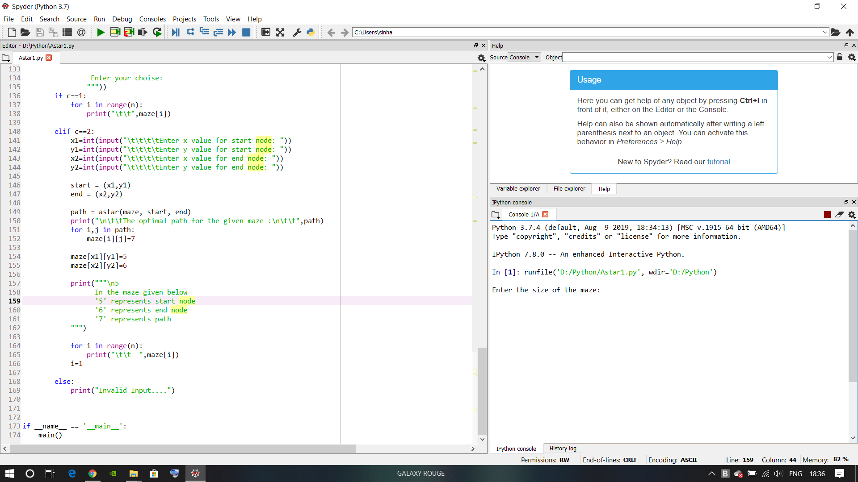

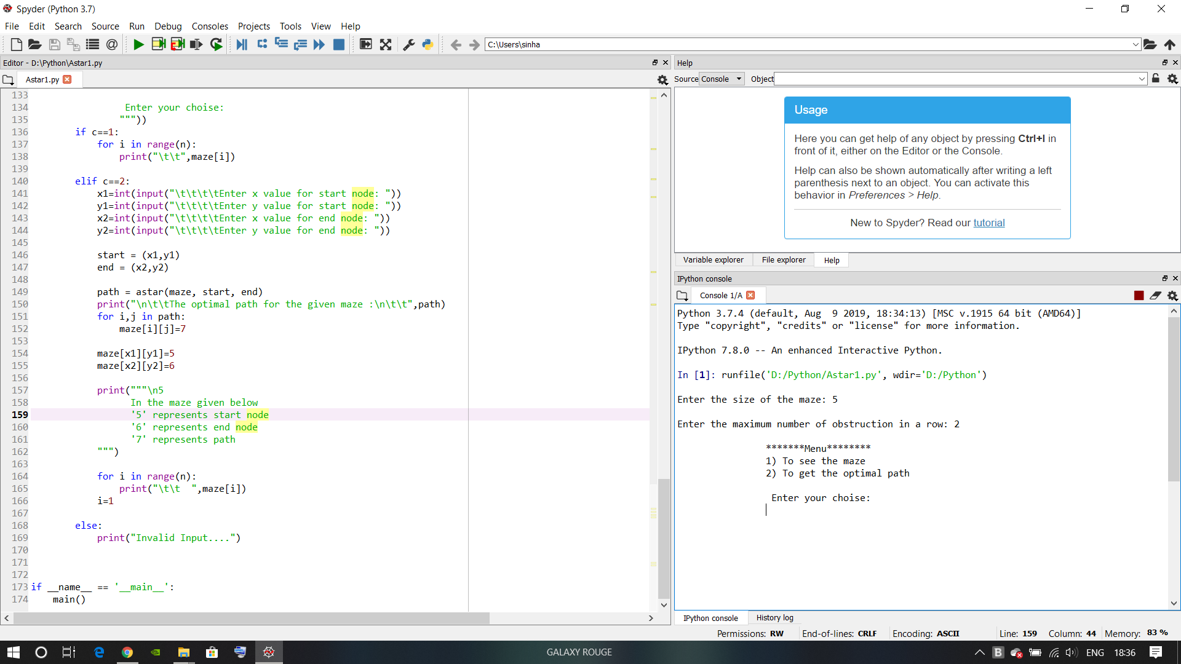

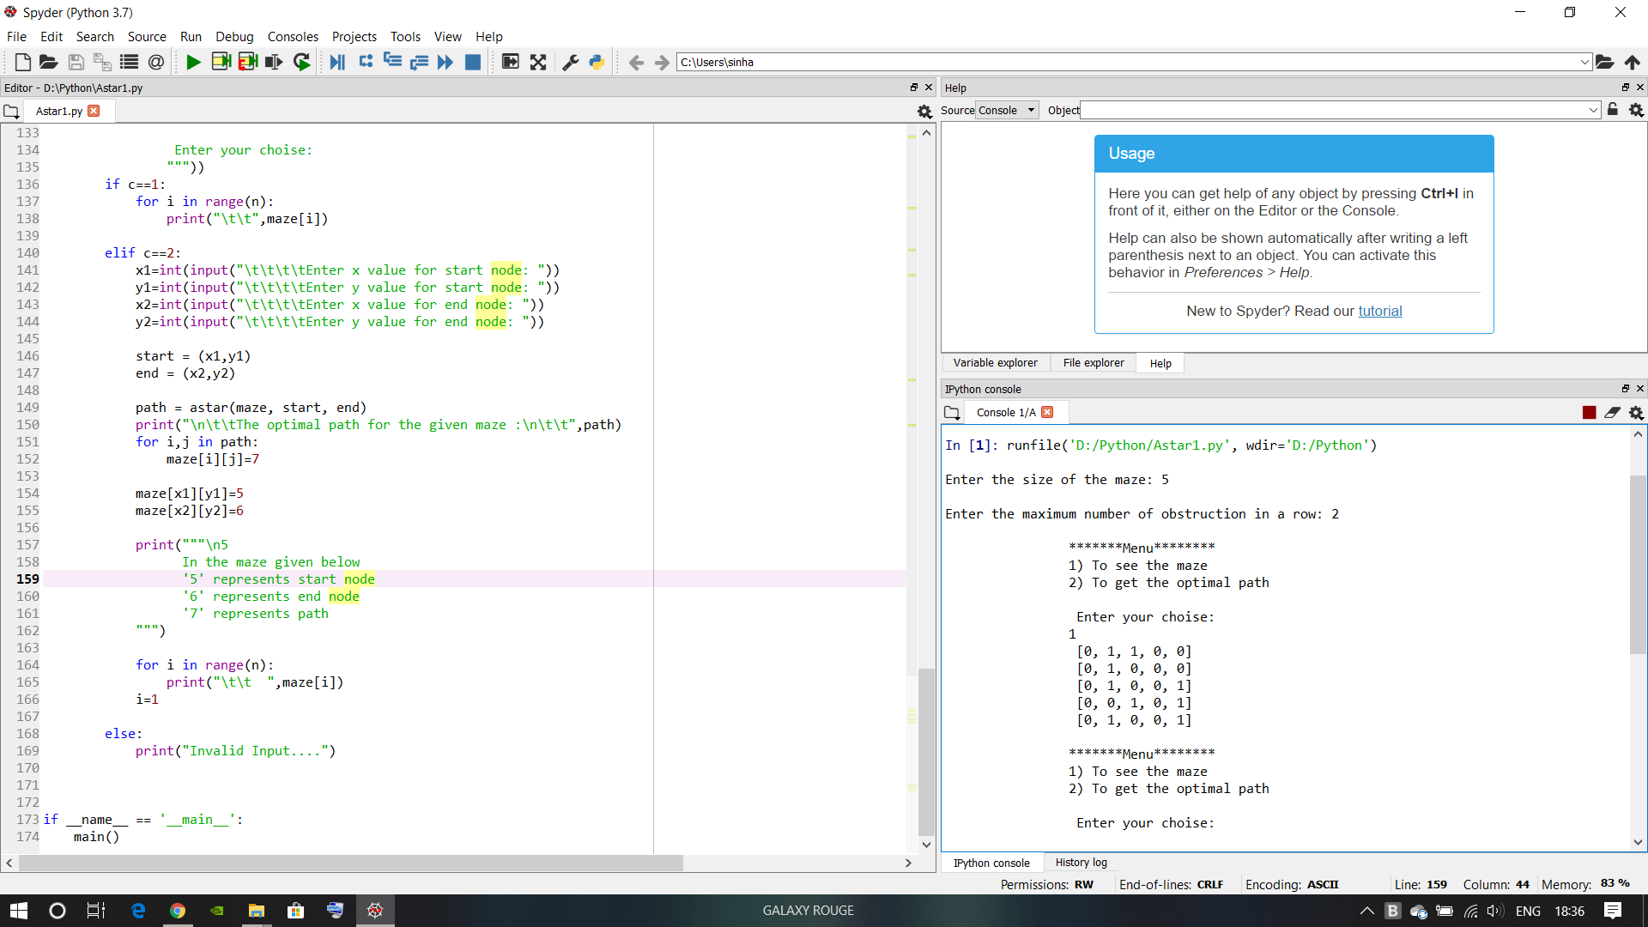

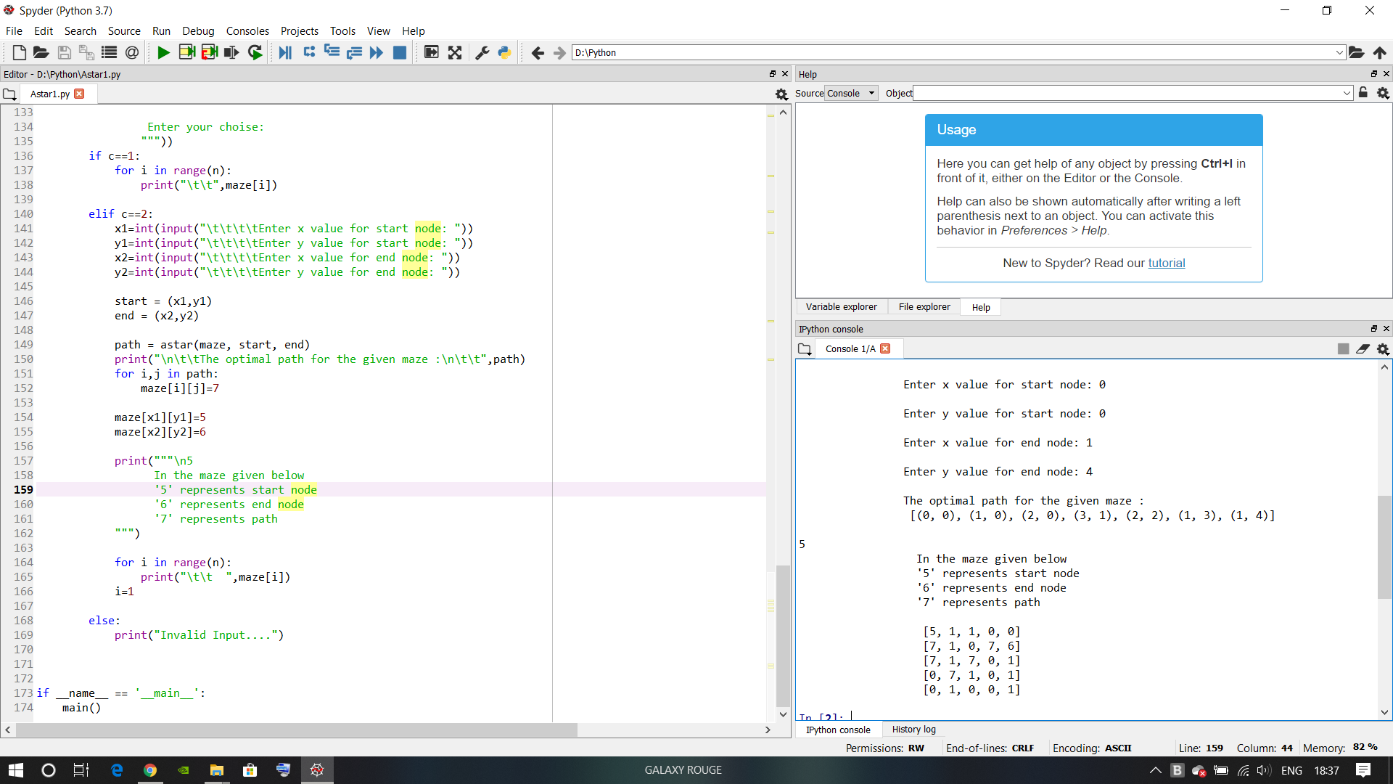

IMORTANT LIBRARIES USED

The library used to implement this code are as follows:

from random import randint

this function is used in the create maze function where the randint is used to get a random column number per row to place the blocked path

TEAM RESPONSIBILITIES

The given project was a solo project so all the work for the implementation is done by me alone

REFERENCES

The given project was implemented with the help of following:

[www.geeksforgeeks.com](http://www.geeksforgeeks.com) for astar algorithm

[www.w3schools.com](http://www.w3schools.com) for codes in python

[www.google.com](http://www.google.com) for related searches

<https://github.com/Galaxyrogue/AI-Project-Astar.git> the git hub repository